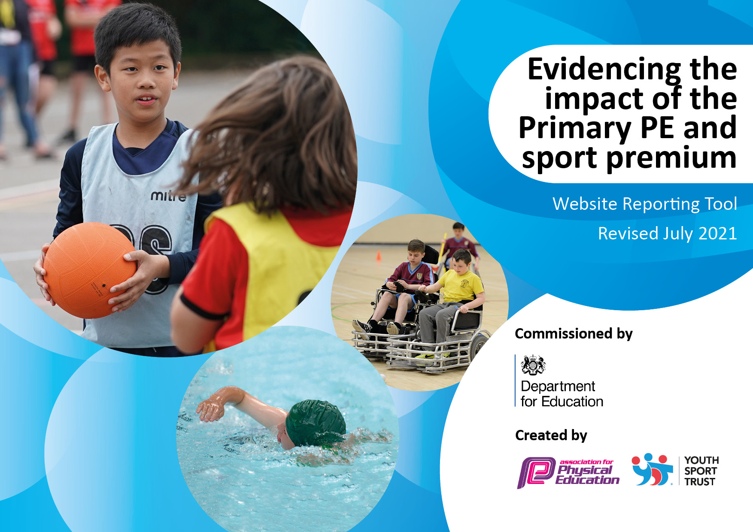
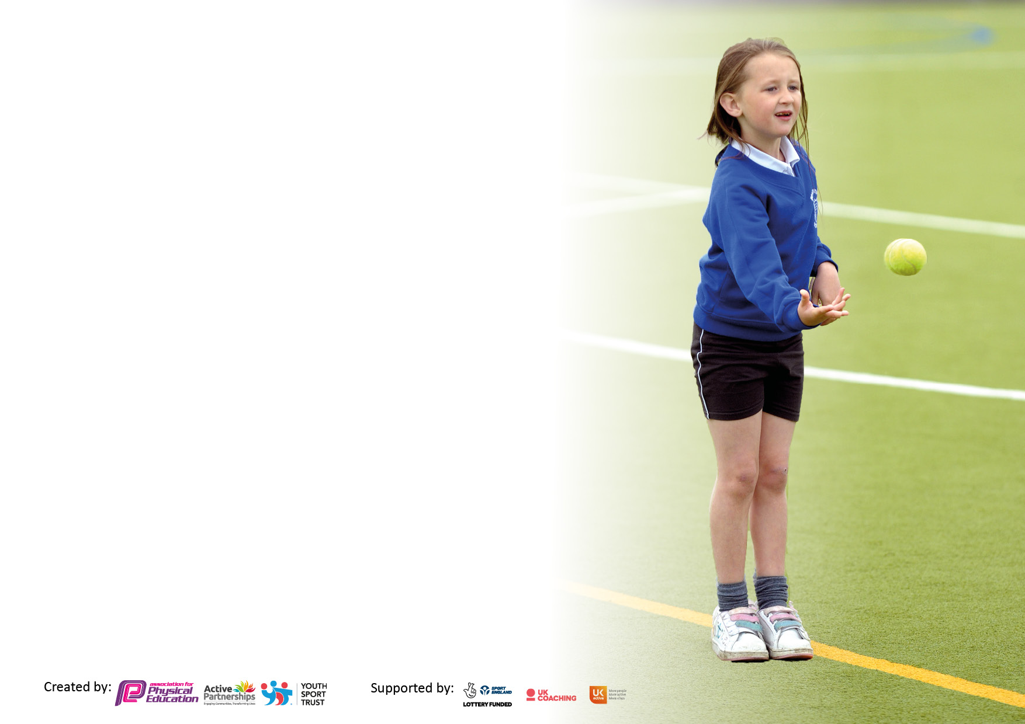

It is important that your grant is used effectively and based on school need. The Education Inspection Framework makes clear there will be a focus on ‘whether leaders and those responsible for governors all understand their respective roles and perform these in a way that enhances the effectiveness of the school’.

Under the Quality of Education Ofsted inspectors consider:
Intent - Curriculum design, coverage and appropriateness
Implementation - Curriculum delivery, Teaching (pedagogy) and Assessment
Impact - Attainment and progress

To assist schools with common transferable language this template has been developed to utilise the same three headings which should make your plans easily transferable between working documents.

Schools must use the funding to make additional and sustainable improvements to the quality of Physical Education, School Sport and Physical Activity (PESSPA) they offer. This means that you should use the Primary PE and sport premium to:

- Develop or add to the PESSPA activities that your school already offer
- Build capacity and capability within the school to ensure that improvements made now will benefit pupils joining the school in future years
- The Primary PE and sport premium should not be used to fund capital spend projects; the school’s budget should fund these.

Pleasevisitgov.ukfortherevisedDfEguidanceincludingthe5keyindicatorsacrosswhichschoolsshoulddemonstrate animprovement.Thisdocumentwillhelpyoutoreviewyourprovisionandtoreportyourspend.DfEencouragesschools to use this template as an effective way of meeting the reporting requirements of the Primary PE and sport premium.

We recommend you start by reflecting on the impact of current provision and reviewing the previous spend.

Schools are required to publish details of how they spend this funding, including any under-spend from 2019/2020, as well as on the impact it has on pupils’ PE and sport participation and attainment. All funding must be spent by 31st July 2022.

We recommend regularly updating the table and publishing it on your website throughout the year. This evidences your ongoing self-evaluation of how you are using the funding to secure maximum, sustainable impact. Final copy must be posted on your website by the end of the academic year and no later than the 31st July 2021. To see an example of how to complete the table please click HERE.
Created by: Supported by:

Details with regard to funding
Please complete the table below.

Total amount carried over from 2019/20 | £0
Total amount allocated for 2020/21 | £17,097
How much (if any) do you intend to carry over from this total fund into 2021/22? | £17,097
Total amount allocated for 2021/22 | £17,097
Total amount of funding for 2021/22. To be spent and reported on by 31st July 2022. | £17,097
Swimming Data
Please report on your Swimming Data below.

Meeting national curriculum requirements for swimming and water safety.

N.B. Complete this section to your best ability. For example you might have practised safe self-rescue techniques on dry land which you can then transfer to the pool when school swimming restarts.
Due to exceptional circumstances priority should be given to ensuring that pupils can perform safe self rescue even if they do not fully meet the first two requirements of the NC programme of study
What percentage of your current Year 6 cohort swim competently, confidently and proficiently over a distance of at least 25 metres?  N.B. Even though your pupils may swim in another year please report on their attainment on leaving primary school at the end of the summer term 2020.  Please see note above | 71%
What percentage of your current Year 6 cohort use a range of strokes effectively [for example, front crawl, backstroke and breaststroke]?  Please see note above | 67%
What percentage of your current Year 6 cohort perform safe self-rescue in different water-based situations? | 67%
Schools can choose to use the Primary PE and sport premium to provide additional provision for swimming but this must be for activity over and above the national curriculum requirements. Have you used it in this way? | No

Action Plan and Budget Tracking
Capture your intended annual spend against the 5 key indicators. Clarify the success criteria and evidence of impact that you intend to measure to evaluate for pupils today and for the future.

Academic Year: 2022/23 | Total fund allocated: £17,097 | Date Updated: July 2023
Key indicator 1: The engagement of all pupils in regular physical activity – Chief Medical Officers guidelines recommend that primary school pupils undertake at least 30 minutes of physical activity a day in school |  |  |  | Percentage of total allocation:
 |  |  |  | 44%
Intent | Implementation |  | Impact
Your school focus should be clear what you want the pupils to know and be able to do and about  what they need to learn and to  consolidate through practice: | Make sure your actions to achieve are linked to your intentions: | Funding allocate: | Evidence of impact: what do pupils now know and what can they now do? What has changed? | Sustainability and suggested next steps:
To support children’s physical and mental well-being, improved levels of concentration as well as physical fitness.  All children encouraged to increase their fitness through internal competitions.  To provide after school sporting clubs for children by staff and external sports coaches. To purchase equipment to enable the clubs to function.  To purchase new equipment to develop a wider range of sports and activities available to all pupils during their PE lessons.  To purchase new playground equipment for EYFS, KS1 and KS2. | Imoves is a comprehensive online platform which keeps children active in the classroom throughout the day, enabling short breaks throughout the day.  Inter-house sporting competitions throughout the year, for all children, i.e.: cricket, rounders, athletics, NAK, Bocca.  Wide variety of after school clubs, catering for different sporting interests: gymnastics, , dance, multi-sports, Yoga,  Bocca, NAK, cricket, table tennis.  New equipment needed for games including balls, hoops, beanbags, quoits, dance ribbons, tennis balls, table tennis bats and balls, street hockey equipment  Purchase equipment ensuring it is suitable for the range of ages and abilities throughout the school. | £1152.00  £600 for internal staffing release.  £ 2000  £2000  £1700 | IMoves gives children active breaks in/ between lessons to increase physical activity.  Termly internal competitions to be organised where all children encouraged to be the best they can be.  Demonstration of leadership, teamwork and communication skills. Competition where the children are encouraged to ‘beat their best’.  Children are more active during lessons as there is enough equipment for all children to be involved. Wider range of lessons and clubs can be delivered with equipment on offer, for example, cricket.  Children make good progress  across the PE curriculum and can  apply their skills to a variety of  sports.  Playtime boxes have been made available so that equipment is easily accessible to promote active playtimes and lunchtimes. | PE lead to monitor impact of IMoves sessions and PE/Games lessons across the school – complete staff and pupil voice for IMoves.  LD to adapt competition to  include milestone competitions  as well as in class.  Increased confidence for all children who participated.  Staff continue to deliver the  curriculum to a high quality.  Top up boxes as required.
Key indicator 2: The profile of PESSPA being raised across the school as a tool for whole school improvement |  |  |  | Percentage of total allocation:
 |  |  |  | 16%
Intent | Implementation |  | Impact
Your school focus should be clear what you want the pupils to know and be able to do and about  what they need to learn and to  consolidate through practice: | Make sure your actions to achieve are linked to your intentions: | Funding allocated: | Evidence of impact: what do pupils now know and what can they now do? What has changed? | Sustainability and suggested next steps:
Ensure all children are aware of the importance of a healthy lifestyle, including both diet and regular exercise.  Outdoor Adventure - Tattenhall | Introduce a healthy eating week. Focus on dangers of obesity, smoking and other such activities that undermine pupils’ health.  Years 3-5 were given the opportunity to take part in a day of outdoor adventure activities. | £350 for resource and staff to run.  £2400 | Increased awareness of the importance of healthy lifestyles re positive food choices.  Majority of pupils had the opportunity to take part in a new experience. Pupils were able to develop and flourish in an environment where feeling safe, building trusting relationships and having confidence to take risks. | Ensure to plan similar event next year. Possibly invite health practioner’s into school  To plan Outdoor Adventure again for residential. Teachers to use skills learnt as part of Outdoor Adventure lessons.

Key indicator 3: Increased confidence, knowledge and skills of all staff in teaching PE and sport |  |  |  | Percentage of total allocation:
 |  |  |  | 12%
Intent | Implementation |  | Impact
Your school focus should be clear | Make sure your actions to | Funding | Evidence of impact: what do | Sustainability and suggested
what you want the pupils to know | achieve are linked to your | allocated: | pupils now know and what | next steps:
and be able to do and about | intentions: |  | can they now do? What has
what they need to learn and to |  |  | changed?
consolidate through practice:
High quality specialist to deliver lessons and working alongside staff. | Coaches to focus on delivering games for ECT teachers CPD.  Other specialist coaches include – Cricket coaching, skipping, martial arts. Team teaching opportunities. | £2000 | Children taking part in lessons that are confidently delivered by staff Teachers confidently delivering lessons with increased confidence and skills. | Children are accessing a wider variety of active sports and experiences allowing them to find the physical activity they enjoy to encourage them to become confident taking part in daily physical activity.
Key indicator 4: Broader experience of a range of sports and activities offered to all pupils |  |  |  | Percentage of total allocation:
 |  |  |  | 26%
Intent | Implementation |  | Impact
Your school focus should be clear | Make sure your actions to | Funding | Evidence of impact: what do | Sustainability and suggested
what you want the pupils to know | achieve are linked to your | allocated: | pupils now know and what | next steps:
and be able to do and about | intentions: |  | can they now do? What has
what they need to learn and to |  |  | changed?
consolidate through practice:
Minibus to travel to sports competitions. This includes supply cover to enable staff to go to sporting events.  Swimming Pool, transport and cover. | Minibus needed to attend even  To provide Swimming lessons for all KS2 children, to help them swim 25M or more. | £280 minibus  £164 supply  Transport £3,640  Pool £361.25 | A very successful event – children coming 4th and were very excited to come back to school to share their achievement.  Children to feel confident and safe around water.  Assessment data shows a big improvement on previous data with 71% of children swimming 25M or more. | At the beginning of the year, highlight across the year, sporting events to attend – booked in advance.  To continue with lessons next year and plan in booster session if need be. Advise parents of where they can go for lessons outside of school.

Key indicator 5: Increased participation in competitive sport |  |  |  | Percentage of total allocation:
 |  |  |  | 2%
Intent | Implementation |  | Impact
Your school focus should be clear | Make sure your actions to | Funding | Evidence of impact: what do | Sustainability and suggested
what you want the pupils to know | achieve are linked to your | allocated: | pupils now know and what | next steps:
and be able to do and about | intentions: |  | can they now do? What has
what they need to learn and to |  |  | changed?
consolidate through practice:
To buy into Halton School Games package. | Plan which competitions we would like to take part in through the year. | £ 450 | Competitions attended: -Cricket tournament.  Bocca/NAK got cancelled. | Increased participation with intra and inter competitions.

Signed off by
Head Teacher: | Louisa Aldridge
Date: | Sep 2023
Subject Leader: | Lindsey Davies
Date: | July 2023
Governor: | Colin Lloyd
Date: | 4.10.23

